|  |  |
| --- | --- |
| **Employee Project Management System** | **Abstract**  This dataset provides a structured representation of employee details and project assignments within a company. It consists of two main tables: Employees and Projects, capturing key information related to personnel and their respective project engagements.  **Sakshi Kamble**  **SQL PROJECT** |

**\* Summary:**

* **The dataset represents a company where employees from different departments work on various projects.**
* **The Employees table gives a good overview of the workforce, with a mix of junior and senior employees in different roles.**
* **The Projects table shows how employees are assigned tasks with varying complexities and budgets, giving insight into resource allocation and project management within the company..**

* Employees Table:

This table stores information about 22 employees, including their employee_id, first_name, last_name, department, salary, age, and years of experience (experience_years). Employees are from various departments like IT, Finance, HR, Marketing, and Operations. Their salaries range from ₹55,000 to ₹85,000, with experience varying from 2 to 18 years, showing a diverse mix of skill levels and pay scales.

* Projects Table:

This table records the projects assigned to these employees. Each project has a unique project_id, references an employee_id (linking to the employee working on the project), and includes the project's name (project_name), its duration in months (project_duration_months), and the allocated budget (budget). The projects vary in duration from 3 to 9 months, with budgets ranging from ₹50,000 to ₹250,000. The projects are distributed across different areas, such as Website Development, Financial Audits, Marketing Campaigns, and Data Analytics Implementation.

**-1)Select All Records:**

Write a SQL query to retrieve all the details of the employees in the Employees table.

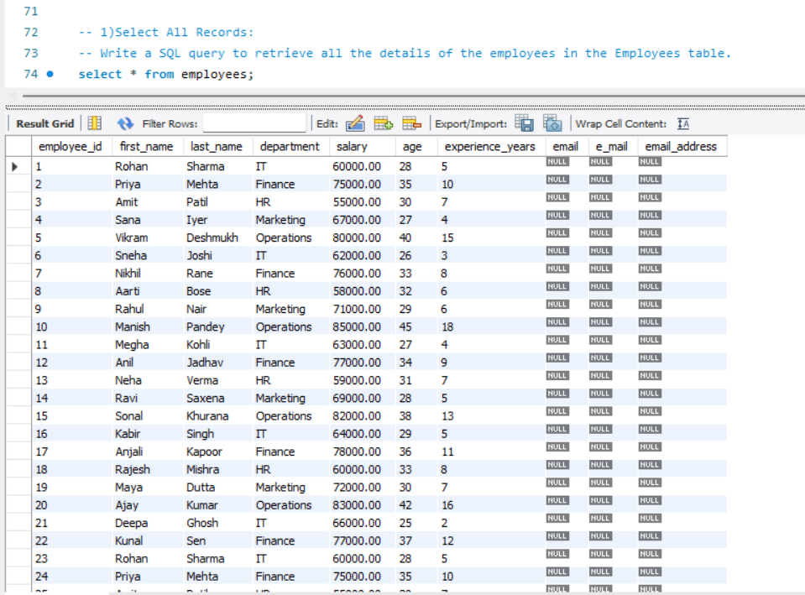

**2)Find Employees by Department:**

Write a query to retrieve the first_name, last_name, and department of employees working in the IT department.

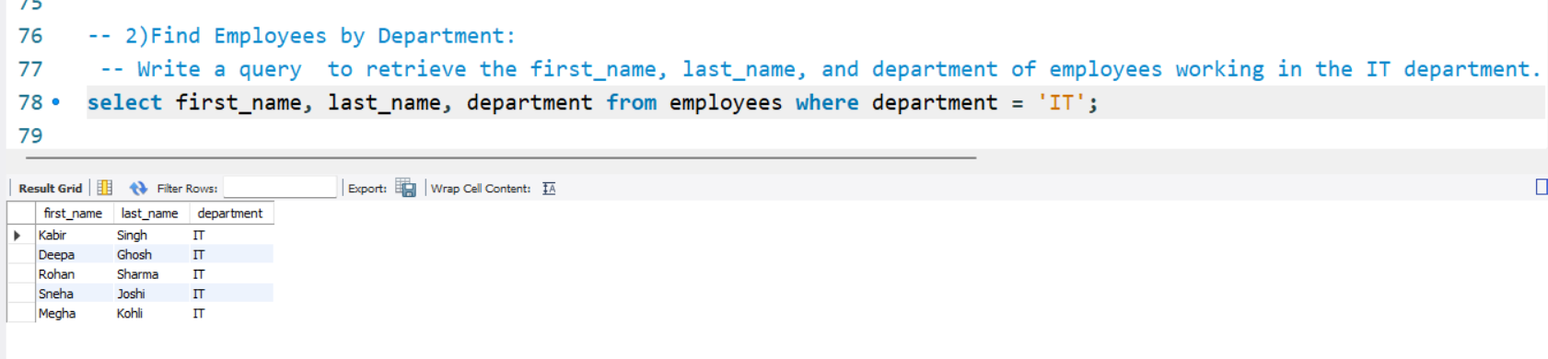

**3)Calculate the Average Salary:**

Write a query to calculate the average salary of employees in the Finance department.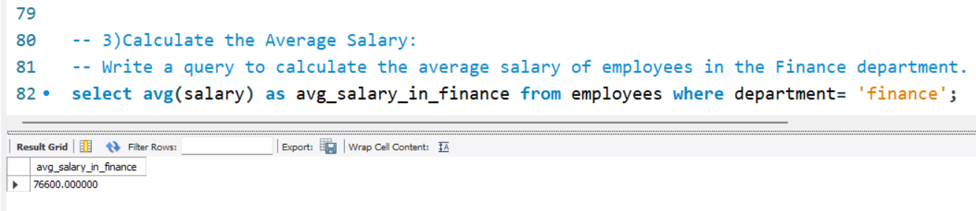

4)Find Employees with More Than 5 Years of Experience:

Write a query to find employees who have more than 5 years of experience, displaying their first_name, last_name, and experience_years.

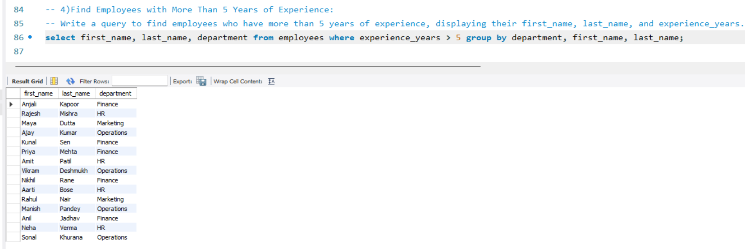

5)Retrieve the Employee with the Highest Salary:

Write a SQL query to find the employee with the highest salary in the Employees table.

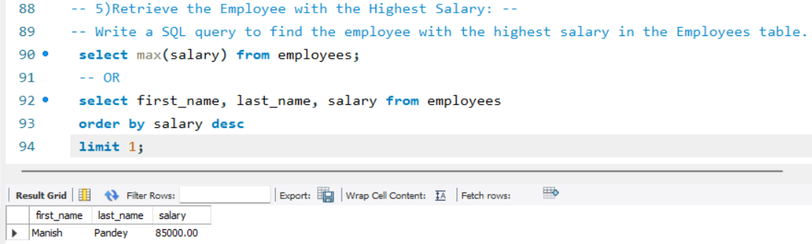

**6)Count the Number of Employees in Each Department**:

Write a SQL query to count the number of employees in each department.

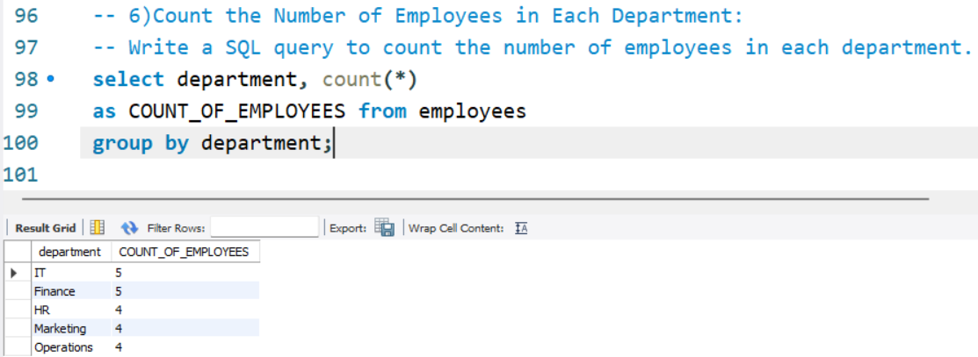

**7)Find Employees Aged Between 25 and 35:**

Write a query to retrieve the names and ages of employees who are between 25 and 35 years old.

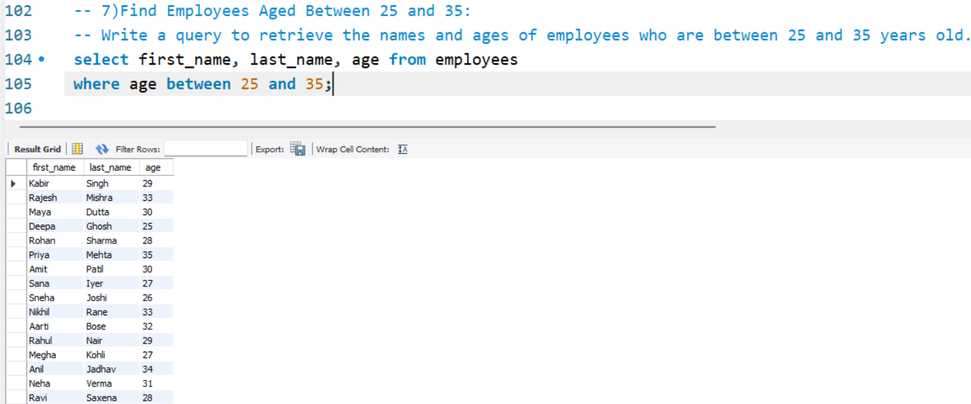

8)Find Employees with a Salary Greater than the Average Salary:

Write a query to find employees whose salary is greater than the average salary of all employees.

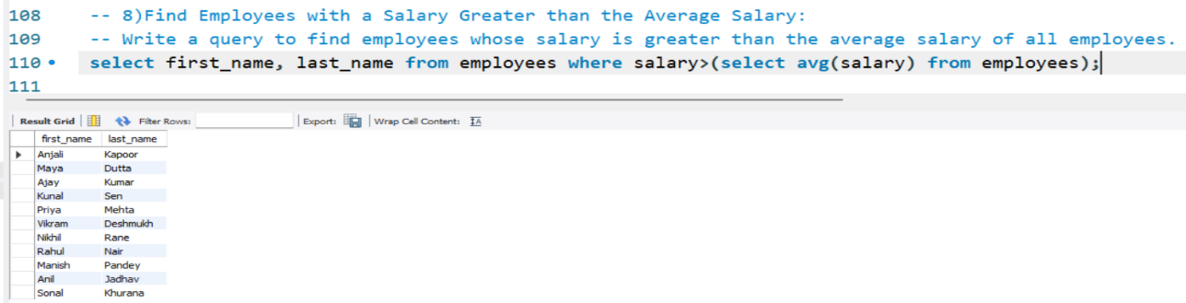

**9)Find Employees with the Maximum Salary in Each Department:**

Write a query to find the employee(s) with the maximum salary in each department.

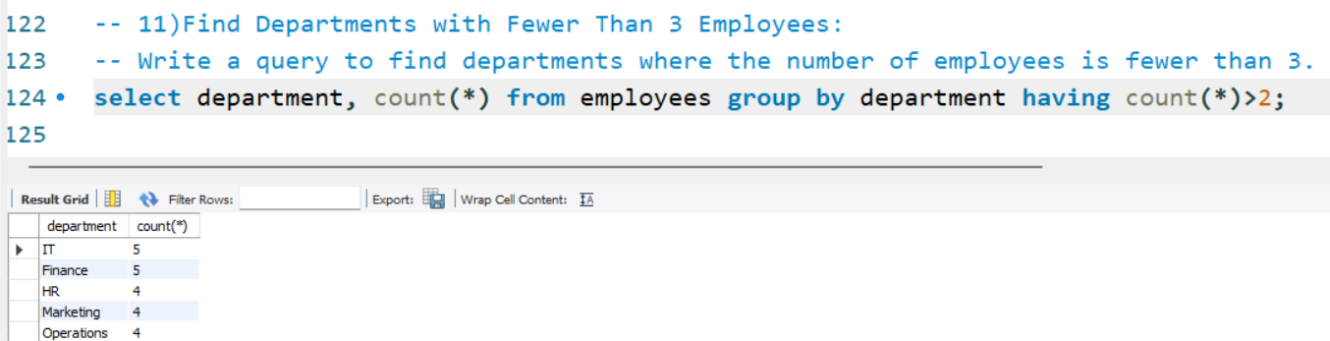

**11)Find Departments with Fewer Than 3 Employees:**

Write a query to find departments where the number of employees is fewer than 3.

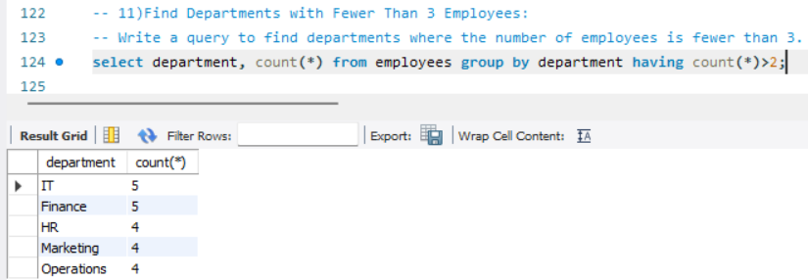

**12)List Employees in Departments with an Average Salary Greater Than $70,000:**

Write a query to find employees working in departments where the average salary is greater than $70,000.

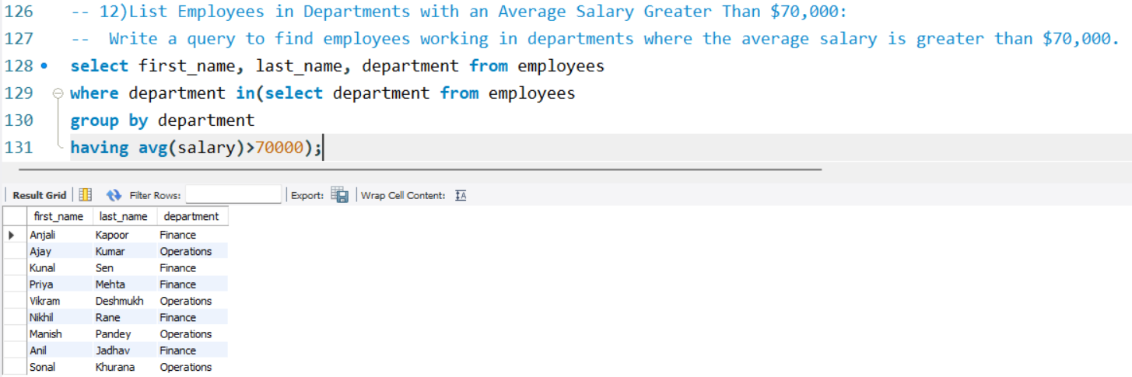

**13)Find the Oldest Employee in the IT Department:**

Write a query to find the oldest employee in the IT department.

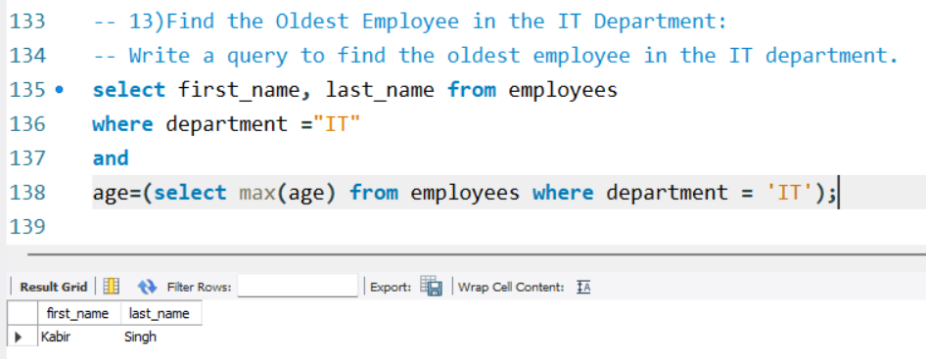

**14) Inner Join Questions**

-- List All Employees with Their Projects: Write a query to display the first name, last name, project name, and budget of all employees who are assigned to projects.

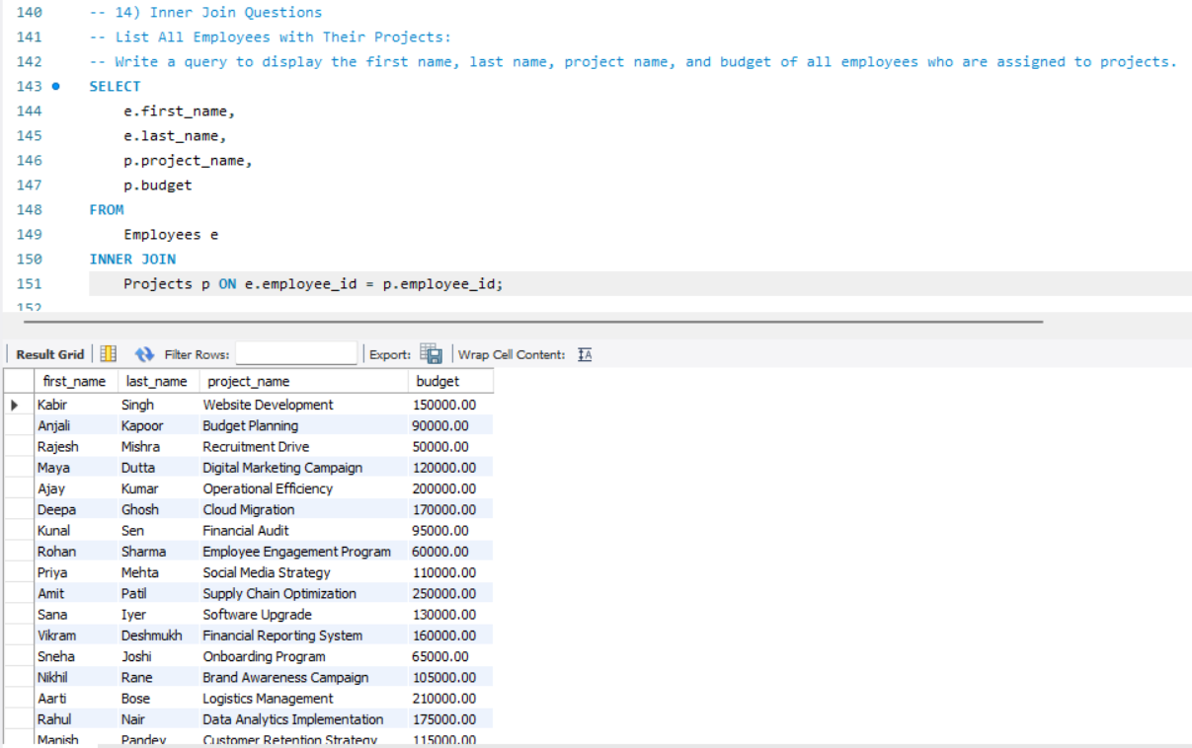

**15) Count of Projects per Department:**

-- Create a query that counts the number of projects each department is involved in.

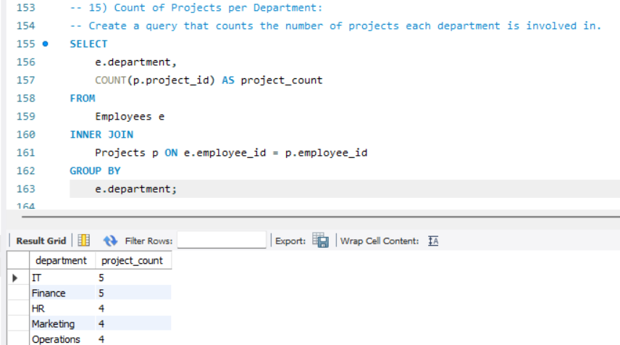

**16) Left Join Questions**

-- List Employees Without Projects: Write a query to list all employees and their assigned projects, including those employees who do not have any projects assigned. Show 'No Project' for employees without projects.

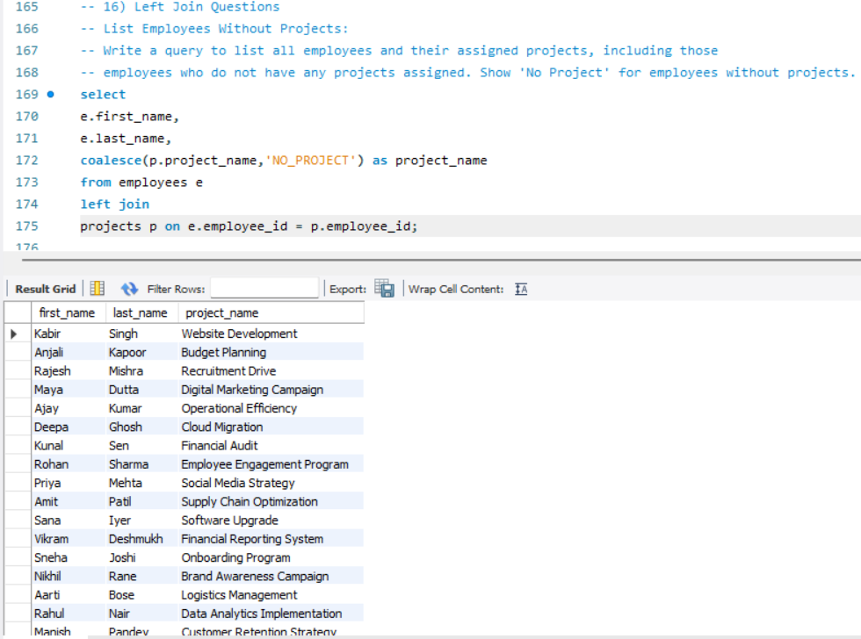

**17) Right Join Questions**

-- List All Projects with Employee Details: Write a query to list all projects along with employee details. Include projects that may not have an assigned employee.

